Software Requirements Specification for

Online Student Materials Management System

Table of Contents

1. Introduction 1

1.1 Purpose of this document 1

1.2 Scope of Project 1

1.3 Intended Audience 1

1.4 References 1

1.5 Overview 1

2. General Description 2

2.1 Product Perspective 2

2.2 Product Functions 3

2.2 User Classes and Characteristics 4

2.3 Operating Environment 5

2.4 General Constraints 5

2.6 Assumptions and Dependencies 6

3. Specific Requirements 6

3.1 Functional Requirements 6

3.1.1 User Interface………………………………………………………………6

3.1.2 Architecture………………………………………………………………..7

3.1.3 Data Entry………………………………………………………………….7

3.1.4 Report Generation…………………………………………………………..7

3.2 Performance Requirements 8

3.3 Design Constraints 8

3.4 Security Requirements 8

3.5 Reliability 8

# Introduction

## Purpose of this document

The purpose of this Software Requirements Specification (SRS) document is to provide a detailed overview of our web-based platform, designed to enable students from various universities to access and share educational materials related to their curriculum. This includes syllabi, textbooks, lecture notes, exam papers, and other relevant study materials. The document outlines functional and non-functional requirements, intended users, system features, constraints, and interaction with external applications. This SRS aims to ensure that developers, project managers, and stakeholders have a clear understanding of the system's capabilities, facilitating a streamlined development process that meets the project's objectives and user needs.

## Scope of Project

The project, herein referred to as "CampusCollab," is a web-based platform that allows university students to effortlessly search, download, and upload academic materials corresponding to their specific course requirements. The website will feature a comprehensive database of educational resources categorized by university, semester, course, and type of material. Key functionalities include user registration and authentication, advanced search capabilities, material upload and download, user feedback systems, and administrative moderation tools. The scope encompasses the development of a responsive web application that supports diverse user devices, ensuring accessibility and usability across different platforms.

## Intended Audience

The primary audience for the CampusCollab includes:

* **University Students:** Seeking access to a wide range of study materials for their academic courses.
* **Educational Institutions:** Universities and colleges that wish to make their curriculum materials easily accessible to their students.
* **Faculty Members:** Looking to share educational content with students and enhance the learning experience.
* **Developers and Technical Staff:** Responsible for developing, maintaining, and updating the website.
* **Project Stakeholders:** Including investors, educational policymakers, and anyone interested in the project's success and alignment with educational standards.

## References

1. Exinfm “Software Requirements Specification Document Guidelines SRS Specific Guidelines”, exinifm, 2024
2. "IEEE Guide for Software Requirements Specifications," in IEEE Std 830-1984 , vol., no., pp.1-26, 10 Feb. 1984
3. Y. Li, H. Zheng, T. Yang and Z. Liu, "Design and Implementation of a Library Management System Based on the Web Service," 2012 Fourth International Conference on Multimedia Information Networking and Security, Nanjing, China, 2012

## Overview

The remainder of this document is structured as follows: Section 2 details the overall description of the project, including product perspective, product functions, user characteristics, constraints, assumptions and dependencies. Section 3 elaborates on the specific requirements, including system features, user interaction, functional requirements, performance requirements, and security requirements. Appendices and indexes provide supplementary information and a glossary of terms used throughout the document.

# General Description

Building upon the structure outlined in the introduction, the General Description section of the SRS document further elaborates on the CampusCollab platform. This section aims to provide a comprehensive understanding of the product's environment, functionality, user interaction, and constraints.

## Product Perspective

CampusCollab is designed as a self-contained, web-based platform that integrates seamlessly with existing educational ecosystems. It operates independently but can potentially link with university databases and educational resource repositories to facilitate the exchange of information. The system is envisioned as a central hub for academic resources, enabling students to find and share materials without navigating through multiple systems.

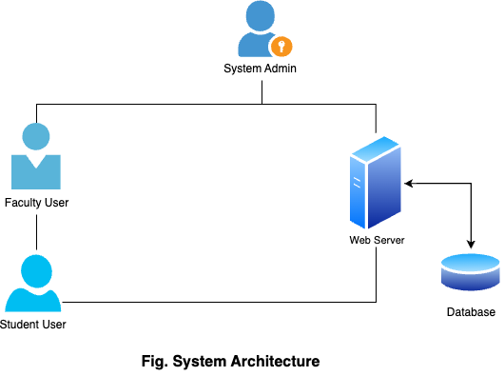

Its architecture is designed to support scalability, allowing for the addition of new universities, courses, and materials as the platform grows. Interoperability with educational standards and systems (e.g., Learning Tools Interoperability (LTI)) is considered to enhance its utility and adoption.

## Product Functions

CampusCollab offers a wide range of functionalities tailored to its users' needs:

* **User Registration and Authentication:** Secure sign-up/login mechanisms for students, faculty, and administrators.
* **Advanced Search Capabilities:** Users can search for materials based on university, semester, course, and document type.
* **Material Upload and Download:** Facilitates the uploading and downloading of study materials, including syllabi, lecture notes, textbooks, and exam papers.
* **Course and Material Management:** Allows administrators and faculty to manage courses, including adding new materials and moderating user uploads.
* **User Profiles and Customization:** Users can customize their profiles and settings to receive recommendations and updates on relevant materials.
* **Feedback and Rating System:** Users can rate materials and provide feedback, enhancing the quality and relevance of resources.

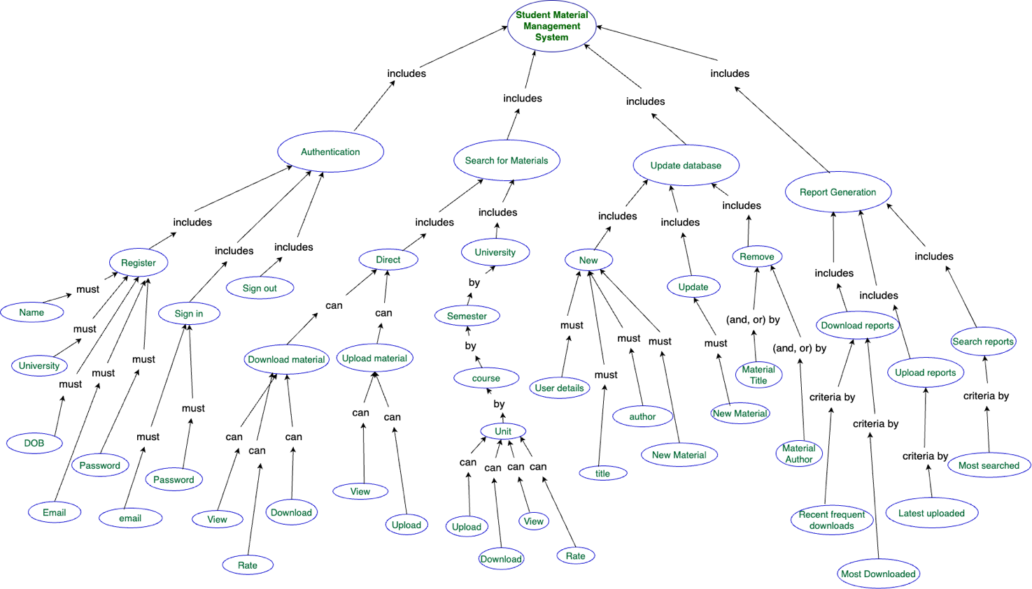

## User Classes and Characteristics

* **Students:** Seeking convenient access to study materials. They require a user-friendly interface to quickly find and download content.
* **Faculty Members:** Interested in sharing educational content with their students and monitoring the usage and feedback of their materials.
* **Administrators:** Responsible for managing the platform's content, user accounts, and system security. They need robust tools to oversee platform operations effectively.
* **Technical Users:** Include developers and IT staff who maintain and update the website. They are interested in system performance, scalability, and integration capabilities.

|  |  |  |  |
| --- | --- | --- | --- |
| **Type of User** | **User Characteristics** | **User Technical Expertise** | **How the user characteristics and technical expertise affect the functionality** |
| Students | Seek convenient access to study materials and a user-friendly interface for quick content retrieval. | Basic to intermediate: able to navigate websites, search for information, and perform downloads/uploads. | The system must have a straightforward interface with an efficient search function, and the ability to handle multiple simultaneous user sessions without performance issues. |
| Faculty Members | Interested in sharing content and monitoring usage/feedback. | Intermediate: capable of utilizing educational platforms, uploading content, and analyzing user engagement data. | The platform should allow faculty to easily upload educational materials and have access to tools for tracking and analyzing student engagement with the materials. |
| Administrators | Manage content, user accounts, and system security. | Advanced: proficient in system administration, user management, and understanding of security protocols. | Requires comprehensive administrative tools for content management, user account control, and security features to safeguard the system’s integrity. |
| Technical Users | Maintain and update the website, focusing on system performance, scalability, and integration. | Expert: extensive knowledge in software development, system maintenance, and scalability solutions. | The backend architecture must be scalable and modular, with capabilities for integration with other systems and technologies, along with tools for monitoring system performance. |

## Operating Environment

|  |  |  |
| --- | --- | --- |
| Category | **Requirement** | **Description** |
| **Device** | Mobile browser, PC browser | Website should be accessible and functional on both mobile and PC browsers |
|  | Minimum screen resolution | 320x480 for mobile, 1024x768 for PC |
|  | Operating systems | Android 5.0+, iOS 10+, Windows 10+, macOS 10.12+ |
| **Internet Connection** | Download speed | Minimum of 2 Mbps for efficient browsing and downloading |
|  | Upload speed | Minimum of 1 Mbps for uploading materials |
|  | Connection stability | Reliable internet connection with minimal latency |
| **Hardware** | Mobile device | Minimum of 2GB RAM, 16GB storage |
|  | PC | Minimum of 4GB RAM, 50GB storage |
| **Software** | Web browser | Modern browser with JavaScript and cookies enabled |
|  | PDF reader | Ability to open and view PDF files |
|  | File compression/decompression software (optional) | For uploading/downloading compressed files (e.g., ZIP, RAR) |
| **Skills** | Basic computer literacy | Ability to navigate websites, search for information, upload/download files |
|  | Email address | Required for account creation and communication |
| **Accessibility** | Screen reader compatibility | Website should be accessible to users with visual impairments |
|  | Keyboard navigation | Website should be fully navigable using keyboard controls |
|  | Color contrast | Website should meet WCAG guidelines for color contrast |

## General Constraints

* **Compliance and Security:** Must comply with data protection laws (e.g., GDPR) and implement robust security measures to protect user data.
* **Internet Dependency:** Full functionality requires an internet connection, limiting access in areas with poor connectivity.
* **Content Quality Control:** Ensuring the accuracy and reliability of uploaded materials poses a significant challenge.
* **Intellectual Property Rights:** Must navigate copyright laws and university policies regarding the distribution of educational materials.

## Assumptions and Dependencies

* **User Participation:** The platform's success is contingent upon active participation from both students and faculty in uploading and sharing materials.
* **Stable Internet Access:** Assumes users have consistent access to the internet to utilize the platform's features.
* **University Cooperation:** The platform may depend on partnerships with universities to ensure a comprehensive database of materials and to facilitate integration with existing systems.
* **Technological Advancements:** Assumes that the current technological environment will remain stable, without significant disruptions that could necessitate major platform overhauls.

# Specific Requirements

Specific requirements in an SRS outline the detailed, precise functionalities and limitations of a system. They dive deeper than the broader statements of functional requirements, providing concrete specifications for each feature. Instead of stating "search for materials," a specific requirement might detail supported search filters, preview types, and sorting options.

## Functional Requirements

### User Interface

* **SRS-001:** The system shall offer intuitive navigation with clear and concise menu options for different website sections like Home, Search, Upload, etc.
* **SRS-002:** The system shall feature a responsive design, adjusting automatically to different screen sizes and resolutions.
* **SRS-003:** The system shall enable users to search for resources by university, semester, course, and file type, with options to preview documents or explore detailed metadata. Sorting and filtering by upload date, rating, or popularity shall be supported.
* **SRS-004:** The system shall provide a user-friendly interface for uploading study materials, including file size and format restrictions, and optional fields for additional information.
* **SRS-005:** The system shall enable easy downloading of materials in their original format, including tracking of download statistics and a management system for download history.
* **SRS-006:** The system shall allow users to update their profiles, view uploaded materials and download history, and manage their contributions.
* **SRS-007:** The system may include community features such as a material rating system, forums or discussion boards, and a feature to like or bookmark favorite materials.
* **SRS-008:** The system shall provide real-time feedback on user actions (e.g., successful upload/download)
* **SRS-009:** The interface shall include a help section with tutorials and FAQs for new users.

### Architecture

Client

Server

Database

**3-Tier Architecture**

* **SRS-010:** Implement a secure and scalable three-tier architecture using appropriate technologies.
* **SRS-011**: Employ a relational database (e.g., MySQL) to store user data, material metadata, and uploaded files.
* **SRS-012:** Utilize a web server (e.g., nginx) and a programming language (e.g., NodeJS) to develop the website backend.
* **SRS-013:** A caching mechanism shall be considered for improved performance and scalability. The architecture should be modular to easily adapt future functionalities.
* **SRS-014**: Integration with external APIs for additional functionalities (e.g., plagiarism check) shall be supported.
* **SRS-015:** The system architecture shall ensure data encryption in transit and at rest to protect sensitive user information.

### Data Entry

* **SRS-016:** Establish data entry protocols for ensuring consistency and quality of uploaded materials.
* **SRS-017:** Implement validation rules to prevent invalid data from entering the system.
* **SRS-018:** Consider user-friendly data entry methods for uploading materials
* **SRS-019:** Design forms for metadata entry that are intuitive and efficient to complete.

### Report Generation

* **SRS-020:** Develop reports (optional) to track website usage, user activity, and material popularity.
* **SRS-021:** Generate reports for administrators to analyze user behavior and content trends.
* **SRS-022:** Offer downloadable reports in various formats (e.g., PDF, CSV).
* **SRS-023:** The system shall include analytics tools for administrators to visualize data trends over time.

## Performance Requirements

* **SRS-024: T**he system shall be optimized for high performance, with page load times not exceeding 2 seconds under standard usage conditions
* **SRS-025:** The system's infrastructure shall be capable of scaling to accommodate growth in user numbers and data volume without degradation in performance.

## Design Constraints

* **SRS-026:** Designed to perform optimally on standard educational institution servers and user devices, without requiring high-end hardware.
* **SRS-027:** The system should be optimized for performance with the budget limits, balancing cost with usability.
* **SRS-028:** The system should be made in such a way that it should prioritize long-term maintenance and support with widespread community.

## Security Requirements

* **SRS-029:** The system shall implement role-based access control to restrict functionality based on user roles.
* **SRS-030:** All user data shall be anonymized in system logs to protect privacy.
* **SRS-031:** Regular security audits shall be conducted to ensure the system's integrity and protection against vulnerabilities.
* **SRS-032:** Ensure captcha mechanism during sign in, downloading files and upload files to prevent bot attacks.

## Reliability

* **SRS-033:** Keyboard navigation and screen reader support shall be implemented throughout the system.
* **SRS-034:** The system shall check for duplicated uploads before pushing it to the database.
* **SRS-035:** The system shall provide tools for content moderation, allowing administrators to remove inappropriate or copyrighted materials.
* **SRS-036:** Version control for uploaded materials shall be implemented, enabling users to access and compare different versions of a document.